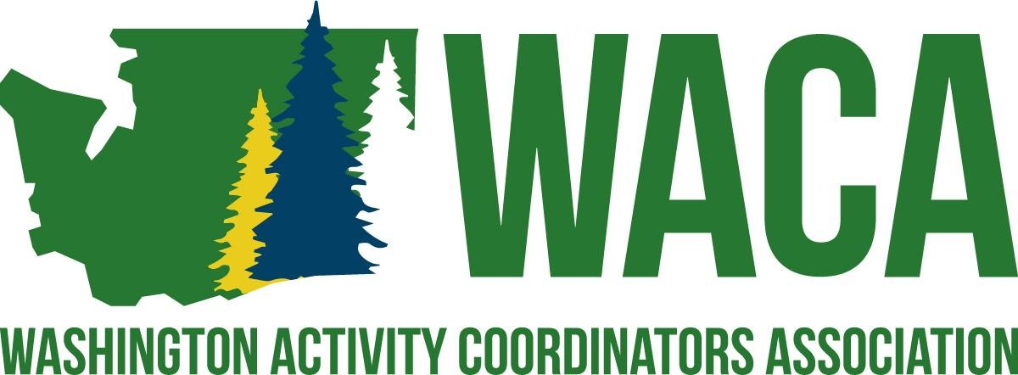

Mission
To serve professionals involved in student activities by providing opportunities and resources for building school culture through project management and professional growth.
​
Vision
WACA supports the development of professionals who are involved in student activities by:
* Hosting a premier conference for all professionals involved in any aspect of student activities.
* Providing professional growth opportunities throughout the year through networking
* Committing to assisting professionals in creating positive school cultures that foster a sense of belonging.

President
Purpose: To preside over the WACA Board, plan and execute the annual conference, and provide guidance and support to the overall health of the WACA organization
- Preside over all meetings of the Association, including:
  - Prepares agendas for all Association meetings.
  - Reviews the Constitution and Bylaws of the Association at spring Executive Board meeting.
  - Communicates with Board members, in a timely manner, regarding required reports, job descriptions, etc.
- Implements the Conference Evaluation that is sent out at the end of the conference.
- Assign and monitor duties and responsibilities of the Board of Directors.
- Make arrangements and coordinates all meetings of the Association, including:
  - Determines dates, times and location of all Association meetings.
  - Makes necessary arrangements for lodging and meals for Association meetings.
  - Communicates with board members, in a timely manner, regarding logistics of Association meetings.
  - Creates and distributes a meeting Agenda, with assistance from Trio.
- Make recommendations for appointed positions, unfilled positions or vacated positions to the Board of Directors for approval, as outlined in the Bylaws of the Association.
- Presides over the Annual Conference, including:
  - With oversight from the Site Committee, they are responsible for the implementation of the meeting/conference contracts with the venue.
  - Keeps clear lines of communication with the President Trio of all pertinent conference information.
  - Assigns duties and responsibilities of the Board of Directors.
  - Makes necessary arrangements for Board lodging and meals.
  - Selects and arranges for delegate conference shirts and Board attire.
  - Selects and arranges for logistics of keynote/general session speakers.
  - Coordinates with conference venue/program coordinator for audio and visual needs and room set-up for general sessions.
  - Coordinates all general session logistics (keynote intros, announcements, banquet, etc.)
  - Coordinates with the WACA banquet presenters to create the agenda and program for the annual banquet.
  - Selects and arranges for delegate materials and supplies (i.e. shirts, notepads, conference bags, logo items, etc.)
  - Partners with Recognition Coordinator to arrange recognition (plaques, certificates, other) of board members whose term of office is ending, as specified in Section 17 of the Association Bylaws.
- Notifies, by letter, the Principal/Supervisor of each Board member of the role in the Association. Notification shall be done by October 15 of each year.
- Assumes the position of Past-President upon the conclusion of the term of President.
- Participates with the Annual Conference Site Committee, as needed.
- After Annual Conference, designates an Area Rep Coordinator and invites to Executive Board Meeting in June.

President-Elect
Purpose: To support the President in whatever needs they have, to be a part of the Presidential Trio, support the annual WACA conference and support the goals of the President and the health of the WACA organization.
- Assumes the responsibilities of the President, in the absence of the President.
- Attends all Board of Directors meetings and Executive Board meetings.
- Actively participates in the planning, implementation, and evaluation of the Annual Conference.
  - Presents information (theme, dates, location) for the following Annual Conference at the closing general session.
  - Assumes the position of President upon the conclusion of the term of President-Elect.
- Works with Area Rep Coordinator to support the Area Reps.
- Participates with the Annual Conference Site Committee, as needed.

Past-President
Purpose: To provide support and guidance to the President, to be a part of the Presidential Trio, support the annual WACA conference and support the goals of the President and the health of the WACA organization.
- Assumes the responsibilities of the President in the absence of both the President and President-Elect.
- Attends all Board of Directors meetings and Executive Board meetings.
- Work with Webmaster to ensure accuracy of the WACA website.
- Actively participates in the planning, implementation and evaluation of the Annual Conference.
  - Coordinates the election process for open board positions.
    - Works with other board members in the advertisement of open positions
    - Prints election materials including position information, applications and ballots.
    - Oversees the counting and tabulation of ballots.
  - Participates with the Annual Conference Site Committee, as needed.
- Works with the President, President-Elect and Program Coordinator in the development of the conference evaluation.
  - With webmaster, Creates and electronically distributes the evaluation to all delegates.
  - Collates the evaluation results
  - Sends the raw data and collated results to the President in a timely manner.
- Picks up duties as assigned by the current President.

Board of Director Responsibilities
All Board Members
- It is a general responsibility that the Board of Directors follow all guidelines and procedures of the Association and that each individual board member meets all responsibilities as outlined in the responsibilities listed below.
- It is expected that board members respond in a timely manner to communications involving Association business.
- Failure to follow guidelines and procedures of the Association or failure to meet minimum job responsibilities is grounds for removal from the board, as outlined in the Bylaws of the Association.
- Actively participates in the planning, implementation, and evaluation of the Annual Conference.
  - Presents breakout session, as needed.
  - Participates in the set-up logistics, decorations, and/or other Annual Conference specific committees, as needed.
  - Volunteers for duties at the Annual Conference as needed to fill in the Responsibility Matrix.
  - Solicits donations for delegate giveaways and prizes.
  - Assists in the recruitment of Presenters.
  - Assists in the recruitment of Partners.

