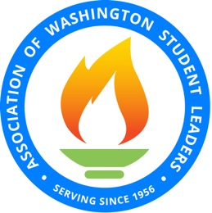
Adviser of the Year Nomination
Association of Washington Student Leaders
a division of the Association of Washington School Principals

Each year the Association of Washington Student Leaders recognizes both an outstanding high school and middle level adviser who have displayed the qualities of service, dedication and leadership to student activities.
To nominate an individual for this award, please submit the following information.
Nomination deadline is December 1st.

High School Adviser Nomination |  |  |  |  |  | Middle Level Adviser Nomination
Name:
School: |  |  |  |  | District:
Official school position:
Number of years as ASB/Leadership adviser:
Brief statement (one paragraph) in support of the nominee:

Signature of nominator: Date: __

Signature of principal: Mr./Ms./Mrs./Dr. Date: __
(Signature indicates support of this nomination)

A more extensive application may be required of finalists.

Please fax or email your application to: James Layman, AWSL Director: jamesl@awsp.org Deadline: December 1st
Phone: 360.497.5323 Fax: 360.497.5324

